**A**

**Project Report**

**On**

**"Student Record Management System"**

**Prepared by**

Om A Tank

**Under the guidance of**

Aishwarya Budhrani

Assistant Professor

A Report Submitted to

Charotar University of Science and Technology

for Partial Fulfillment of the Requirements for the

4th Semester Software Group Project-I (CE244)

**Submitted at**



**CSE**

**DEPSTAR**

**At: Changa, Dist: Anand – 388421**

**November 2020**



**CERTIFICATE**

This is to certify that the report entitled “**Student Record Management System**” is a bonafied work carried out by **Mr. Om A Tank (19DCS147)** under the guidance and supervision of **Assistant Prof. Aishwariya Budhrani** for the subject CE244 **Software Group Project-I** (CE/CSE/IT) of 4th Semester of Bachelor of Technology in **DEPSTAR** at Faculty of Technology & Engineering – CHARUSAT, Gujarat. To the best of my knowledge and belief, this work embodies the work of candidate himself, has duly been completed, and fulfills the requirement of the ordinance relating to the B.Tech. Degree of the University and is up to the standard in respect of content, presentation and language for being referred to the examiner.

|  |  |
| --- | --- |
| Aishwariya Budhrani  Assistant Professor  Department of Computer Science & Engineering  DEPSTAR, Changa, Gujarat. |  |
| Dr. Amit Ganatra  Principal, DEPSTAR  Dean, FTE  CHARUSAT, Changa, Gujarat. | |

**Devang Patel Institute of Advance Technology And Research At: Changa, Ta. Petlad, Dist. Anand, PIN: 388 421. Gujarat**

**DECLARATION BY THE CANDIDATES**

I hereby declare that the project report entitled “**Student Record Management System**” submitted by me to Devang Patel Institute of Advance Technology and Research, Changa in partial fulfilment of the requirement for the award of the degree of **B.Tech** in Computer Science and Engineering, from Devang Patel Department of Computer Science and Engineering, DEPSTAR/FTE, is a record of bonafide CE244 Software Group Project - 1 carried out by me under the guidance of **Assistant** **Prof. Aishwariya Budhrani.** I further declare that the work carried out and documented in this project report has not been submitted anywhere else either in part or in full and it is the original work, for the award of any other degree or diploma in this institute or any other institute or university.

Om Tank (19DCS147)

Prof. Aishwariya Budhrani

Assistant Professor cum Research Fellow

Department of Computer Science and Engineering

Devang Patel Institute of Advance Technology and Research

CHARUSAT, Changa.

**ABSTRACT**

In today’s scenario, **Web development** is the work involved in developing a [Web site](https://en.wikipedia.org/wiki/Web_site) for the [Internet](https://en.wikipedia.org/wiki/Internet) ([World Wide Web](https://en.wikipedia.org/wiki/World_Wide_Web)) or an [intranet](https://en.wikipedia.org/wiki/Intranet) (a private network). Web development can range from developing a simple single [static page](https://en.wikipedia.org/wiki/Static_Web_page) of [plain text](https://en.wikipedia.org/wiki/Plain_text) to complex [web applications](https://en.wikipedia.org/wiki/Web_application), [electronic businesses](https://en.wikipedia.org/wiki/Electronic_business), and [social network services](https://en.wikipedia.org/wiki/Social_network_service). A more comprehensive list of tasks to which Web development commonly refers, may include [Web engineering](https://en.wikipedia.org/wiki/Web_engineering), [Web design](https://en.wikipedia.org/wiki/Web_design), [Web content development](https://en.wikipedia.org/wiki/Web_content_development), client liaison, [client-side](https://en.wikipedia.org/wiki/Client-side_scripting)/[server-side scripting](https://en.wikipedia.org/wiki/Server-side_scripting), [Web server](https://en.wikipedia.org/wiki/Web_server) and [network security](https://en.wikipedia.org/wiki/Network_security) configuration, and [e-commerce](https://en.wikipedia.org/wiki/E-commerce) development. Among Web professionals, "Web development" usually refers to the main non-design aspects of building Web sites: writing [markup](https://en.wikipedia.org/wiki/Markup_language) and [coding](https://en.wikipedia.org/wiki/Computer_programming). Web development may use [content management systems](https://en.wikipedia.org/wiki/Content_management_system) (CMS) to make content changes easier and available with basic technical skills. Web development has also impacted personal networking and marketing. Web sites are no longer simply tools for work or for [commerce](https://en.wikipedia.org/wiki/Commerce), but serve more broadly for communication and [social networking](https://en.wikipedia.org/wiki/Social_networking). Web sites such as [Facebook](https://en.wikipedia.org/wiki/Facebook) and [Twitter](https://en.wikipedia.org/wiki/Twitter) provide users with a platform to communicate and organizations with a more personal and interactive way to engage the public.

So, based on Web Development technology, our group has made up the website named “**Student Record Management System**” which includes the management of the student records of the institute, assignments and notices and also take care of the student records. We will purpose this website on online browser. Any individual can get this website and have the full experience of their management of the records as well as the can update and manage it.

**ACKNOWLEDGEMENT**

We, the developer of this website “Student Record Management System”, with immense pleasure and commitment would like to present the project assignment. The development of this project have given us wide opportunity to think, implement and interact with various aspects of management skills as well as the new emerging technologies.

Every work that one completes successfully stands on the constant encouragement, good will and support of the people around. I hereby avail this opportunity to express my gratitude to number of people who extended their valuable time, full support and cooperation in developing the project.

We express deep sense of gratitude towards our project guide Prof. Aishwariya Budhrani for the support during the whole session of study and development. It is because of her, that we were dedicated to do hard work and adopting some new technologies.

We would also like to thank our mentor Akash Shah for his guidelines throughout the development phase of the website. He helped us, whenever we got stuck in the Web Development Concepts.

They altogether provided me favourable environment, and without them it would not have been possible to achieve the goal.

Thanks,

Om Tank

**TABLE OF CONTENTS**

ABSTRACT 4

ACKNOWLEDGEMENT 5

TABLE OF CONTENTS 6

List of tables ................................................................................................. x

**Chapter 1 Introduction..................................................................................... 8**

1.1 Project Overview ....................................................................................................8

1.2 Objective ................................................................................................................9

1.3 Scope........................................................................................................................9

1.4 Tools and Technologies.........................................................................................10

**Chapter 2 Project Management.................................................................... 11**

2.1 Project Planning ...................................................................................................11

2.1.1 Project Approach and Development...............................................................11

2.1.2 Project Justification .......................................................................................12

2.2 Project Motivation ................................................................................................13

**Chapter 3 System Requirements.................................................................. 14**

3.1 User Characteristics .............................................................................................14

3.2 Hardware and Software requirements...................................................................14

3.2.1 Hardware Specifications.................................................................................14

3.2.2 Software Specifications..................................................................................14

1. Visual Studio Code .........................................................................................14

2. PHP..................................................................................................................15

3. Xampp.............................................................................................................15

4. Bootstrap Framework ......................................................................................16

5. phpMyAdmin...................................................................................................17

**Chapter 4 System Analysis........................................................................... 18**

4.1 System Working and Flowchart of Project............................................................18

**Chapter 5 Implementation and Testing...................................................... 21**

5.1 Implementation of Project .....................................................................................21

**Chapter 6 Future Performance Enhancement........................................... 29**

6.1 Predictions of Website in Future...........................................................................29

**Chapter 7 Conclusion................................................................................... 30**

7.1 Self - Analysis ......................................................................................................30

7.2 Problems and their Solutions …............................................................................30

7.3 Summary ...............................................................................................................31

**CHAPTER 1: INTRODUCTION**

**1.1 PROJECT OVERVIEW**

Web Development is the most immersing and developing feature in the whole world. As far as entertainment website, these also provides to manage the work of the people as well as company. Web sites are no longer simply tools for work or for [commerce](https://en.wikipedia.org/wiki/Commerce), but serve more broadly for communication and [social networking](https://en.wikipedia.org/wiki/Social_networking). There are all sorts of new possibilities as well. So, with this we think to develop a website for the efficiency of institute taking care of the student records and to manage as well deal with it. Student Record Management System (SRMS) is the process of collecting, processing, and storing transmitting relevant information to support the management operations in any organizations. Where it helps to provide accurate and timely information necessary to facilitate the decision-making process and enable the organizations planning, control, and operational functions to be carried out effectively.

* Student Record Management System is the most crucial and important website for the storing and managing the student records. This website heavily depends on the developing content of the person. We have developed this website using the HTML, CSS, PHP and JAVASCRIPT. The website starts with login screen in which we need to login in our website and then get navigated to the home screen. When the home page get loaded, you will see the dashboard containing all the options and a top bar containing the project name as well as some other features.
* The home page of our website contains a dashboard from which we can navigate to all the available options. We also provide the logout button in the top bar through which they can logout their account and can login through different account.
* This website can do the adding and removal of students from admin side. Also, in this website student can login in through there id’s and password and get view their details and get all the assignments and notices available.
* This website is built to think of the institute in the different way and explore that these things can also be done digitally in this era. Mostly, this website is for the institute who want to manage the large contents of their student records as well as make them available to be viewed by their students and get the related educatory docs.

**1.2 OJECTIVE**

Student Management System can be used by educational institutions to maintain their student records easily. Achieving this objective is difficult using the manual system as the information is scattered, can be redundant and collecting relevant information may be very time-consuming. The system is equipped with a robust set of features like attendance tracking, library management, parent portal, etc. These tools help in managing the institute efficiently and accurately. In other words, it saves time, cut fees loss, and other wastages. Most schools use student information systems (SIS) as a standalone tool and use different applications for other purposes like classroom management, online courses management, and more.

As the current scenario prevails almost everywhere in colleges and schools, student management work is found to be done manually by the student counsellors or professors.There is lot of paper work going on everywhere for the same purpose i.e. attendance, lectures, meetings, classes etc. To reduce this stuff we plan to build a native website which performs this tasks to reduce human effort.

**1.3 SCOPE**

* An only authenticated user can have access to certain privileges.
* Reduces the uses of hardcopy of papers.
* Student information can be accessed and known and can be changed at any time.
* Manipulation of the data is possible.
* Can be accessed anywhere and the details can be known with an authorized access only.

**1.4 TOOLS AND TECHNOLOGY USED**

* We have used PHP, HTML, CSS and Bootstrap for making this website.
* For saving the data of students, we have used phpMyAdmin.
* The entire website executes on the XAMPP server.
* To Access the website we can use any type of web browser like Google Chrome or Microsoft Edge or Brave browser.

**CHAPTER 2: PROJECT MANAGEMENT**

**2.1 PROJECT PLANNING**

**2.1.1 PROJECT APPROACH AND DEVELOPMENT**

Here, firstly we don’t know anything the web development and how to do it. So, we thought to refer some of the articles regarding to it. Then, we came to know about the web development using the HTML, CSS and JavaScript. We thought of to refer some of the projects so that we can think of some of the creative ideas using this languages. We think to implement the project using the basic of the web development as we all of the members are new for this languages. So, we think to implement using the HTML, CSS, PHP as the frontend part for the web development as they are the basic and essential part for the frontend part. After that, the main fault was about the database to link with the frontend part. As we all are new, we thought to take a look for the backend part with these languages. So, we refer to some of the articles and we took some guidance from our professor about the backend. After that, we think to take phpMyAdmin for the database. As it is very flexible and very effective for the database with the HTML, CSS and PHP.

We thought of creating this website as the situations around us right now is somewhat different than the regular time. Most of the education in all over the world is nowadays is transforming to online education as we have left with no choice. So, we thought to make a website through which students can get their information in the administrative department and can apply some of the changes in their information. Also, they thought of creating a platform where all materials and books can be uploaded so that students can easily download all the things. In future though, professors can do meeting call and students can join that through their own logins. So, by this points keeping in mind, we thought of creating the website similar somewhere to universities websites and additional things add on to it.

Now, we face the problem from where to start? So, we thought that let’s take some references from the Google as well as from our professors where they guide us well. We approach our project as one of the person from the group will take the responsibility of making and designing part of our website. He will look after all the problems that will appear during the project in the frontend part. While second person will look after the styling of the website and will too look after the creating of the database. While the third person will look after the connecting the database and some bugs and errors of the backend part of the website.

After that, under the guidance of professor and references that we take from Google, we firstly thought of to design a simple layout of the website and of the database too. Then, we started working after the frontend part i.e. creating a website and designing of it. But in the parallel path only, we think to create a database so that as last moment we don’t have to panic about the work. So, one person started to creating a database after consulting the other group members and discussing the database too.

* For the frontend part of the website, we used the basic HTML, CSS for the creating and basic designing of our website. We thought of using Bootstrap framework for the designing of the website. As the properties for designing are in-built and we don’t need to take care of all properties of that page. The central idea is to build the website using this languages for easy use of it. As HTML contains many tags inside it, by using that tags we will be crating the website. HTML comes with a suite of powerful tags, out of which the following are commonly used like anchor, span, heading, style many more.
* Now for the backend part of our website, we had to think much more of it as we don’t know about the backend part of the website and how it works. At last, we thought of using the phpMyAdmin for creating and using the database of it. . A query is a question or inquiry about a set of data. As phpMyAdmin is very efficient and easy to use with PHP language. We use Structured Query Language (SQL) to retrieve meaningful and relevant information from databases. When building a structure, we pull data from tables and fields. The fields are columns in the database table, while the actual data makes up the rows. Here, we need to run mainly CRUD operations in the database. CRUD operations are create, read, update and delete operations perform in our database. Basically, after creating the database, we need to connect the database with the frontend part of our website. And for the connection of the database with the frontend part, we thought that PHP language will help us to connect to it easily. And this works for us too and for the project also. So, the main focus was to connect project totally and present a working model of the website.

**2.1.2 PROJECT JUSTIFICATION**

* As we know, this project clears about the solution of the website of the colleges and universities for managing the data of students and to keep that data in very meaningful manner and very carefully as the data of each and every student is important.
* Here, data of not only students but professors can manage on the website and they can upload all the necessary materials on the website. So that, students can view all these materials and can download it also.
* We can also create online platform where professors can take the necessary lectures and students should join on that meeting through this website only.
* This type of website can help universities and colleges very efficiently as right now the situation around us is not as normal as before so. Education has come to online in all over the world and they can use this website for better enhancement and progress of their university or college.
* They can also create online library where students can get all books as similar as they can get in the library of their own college.

**2.2 PROJECT MOTIVATION**

Maintain a very large record of the students as well as professors is the big task. So, keep the tracking on the data of the students is well known task for it. As we see the current situation around us about the COVID – 19, we can’t let go the education of the students. So, keeping this mind we thought of to provide a website where most of things related to their college and university work gets completed on that only.

Also, students can get all the necessary things from this website only as well as professors too. While the administration of their college or universities can also work on this website by maintaining record of each and every student on this website only. They can create online platform where all data of students get combine and through that they can manage it very well.

We thought of providing all the necessary things as they can get it from college in online website only. So that, they need not have to worry about materials and meetings too. As of right now, there is no platform available for this type of requirement. So we thought of to take up this project and build it up for the better enhancement of the university.

Mainly we should concentrate on the following points:

* REAL-TIME visibility on the website modules.
* TRACKING of data of students as well as professors.
* EFFICIENT use of the details provided on the website.
* CREATING virtual online platform for studying and teaching as well.

**CHAPTER 3: SYSTEM REQUIREMENTS**

**3.1 USER CHARACTERISTICS**

* **Administrators :**

Here, administrators can delete, update or create any new functionalities as they want. They have all the access to the data of their students as well as their professors. They are also responsible for the nature of the environment in the project. They can control the flow of the database and change the query of it at any time. They can manage all the data coming from database.

**3.2 HARDWARE AND SOFTWARE REQUIREMENTS**

**3.2.1 Hardware specification**

* Intel(R) Core(TM) i3-3110M CPU
* 2.4 GHz processor and 512 MB RAM
* 64 – bit Operating System , x64 – based processor
* Windows 7 or above version, Mac OS, Linux, Unix.
* It needs most recent version of Google Chrome, Firefox, Internet Explorer, or safari.
* Graphics Card: Intel or Nvidia
* Hard Drive: 5 Gigabytes
* Network: Broadband Recommended

**3.2.2 Software specification**

1. **Visual Studio Code :**

* Visual Studio Code is a free [source-code editor](https://en.wikipedia.org/wiki/Source-code_editor) made by [Microsoft](https://en.wikipedia.org/wiki/Microsoft) for [Windows](https://en.wikipedia.org/wiki/Windows), [Linux](https://en.wikipedia.org/wiki/Linux) and [MacOS](https://en.wikipedia.org/wiki/MacOS). Features include support for [debugging](https://en.wikipedia.org/wiki/Debugging), [syntax highlighting](https://en.wikipedia.org/wiki/Syntax_highlighting), [intelligent code completion](https://en.wikipedia.org/wiki/Intelligent_code_completion), [snippets](https://en.wikipedia.org/wiki/Snippet_(programming)), [code refactoring](https://en.wikipedia.org/wiki/Code_refactoring), and embedded [Git](https://en.wikipedia.org/wiki/Git). Users can change the [theme](https://en.wikipedia.org/wiki/Theme_(computing)), [keyboard shortcuts](https://en.wikipedia.org/wiki/Keyboard_shortcut), preferences, and install [extensions](https://en.wikipedia.org/wiki/Plug-in_(computing)) that add additional functionality.
* Visual Studio Code includes multiple extensions for FTP, allowing the software to be used as a free alternative for web development. Code can be synced between the editor and the server, without downloading any extra software.
* Visual Studio Code can be extended via [extensions](https://en.wikipedia.org/wiki/Plug-in_(computing)), available through a central repository. This includes additions to the editor and language support. A notable feature is the ability to create extensions that add support for new [languages](https://en.wikipedia.org/wiki/Programming_language), [themes](https://en.wikipedia.org/wiki/Theme_(computing)), and [debuggers](https://en.wikipedia.org/wiki/Debugger), perform [static code analysis](https://en.wikipedia.org/wiki/Static_code_analysis), and add [code linters](https://en.wikipedia.org/wiki/Lint_(software)) using the [Language Server Protocol](https://en.wikipedia.org/wiki/Language_Server_Protocol).
* Instead of a project system, it allows users to open one or more directories, which can then be saved in workspaces for future reuse. This allows it to operate as a [language-agnostic](https://en.wikipedia.org/wiki/Language-agnostic) code editor for any language. It supports a number of programming languages and a set of features that differs per language. Unwanted files and folders can be excluded from the project tree via the settings. Many Visual Studio Code features are not exposed through menus or the user interface, but can be accessed via the command palette.

1. **PHP :**

* The **PHP Hypertext Preprocessor (PHP)**is a programming language that allows web developers to create dynamic content that interacts with databases. PHP is basically used for developing web based software applications. This tutorial helps you to build your base with PHP.
* PHP is a general-purpose scripting language especially suited to web development. It was originally created by Danish-Canadian programmer Rasmus Lerdorf in 1994.
* PHP is a server side scripting language that is embedded in HTML. It is used to manage dynamic content, databases, session tracking, even build entire e-commerce sites.
* It is integrated with a number of popular databases, including MySQL, PostgreSQL, Oracle, Sybase, Informix, and Microsoft SQL Server.
* PHP performs system functions, i.e. from files on a system it can create, open, read, write, and close them. PHP can handle forms, i.e. gather data from files, save data to a file, through email you can send data, return data to the user.You can add, delete and modify elements within your database through PHP. We can access cookies variables and set cookies.

1. **XAMPP:**

* XAMPP is an abbreviation where **X stands for Cross-Platform, A stands for Apache, M stands for**[**MYSQL**](https://www.javatpoint.com/mysql-tutorial)**, and the Ps stand for PHP and Perl**, respectively. It is an open-source package of web solutions that includes Apache distribution for many servers and command-line executable along with modules such as Apache server, [MariaDB](https://www.javatpoint.com/mariadb-tutorial), PHP, and Perl.
* XAMPP helps a local host or server to test its website and clients via computers and laptops before releasing it to the main server. It is a platform that furnishes a suitable environment to test and verify the working of projects based on Apache, Perl, MySQL database, and PHP through the system of the host itself. Among these technologies, [Perl](https://www.javatpoint.com/perl-tutorial) is a programming language used for web development, [PHP](https://www.javatpoint.com/php-tutorial) is a backend scripting language, and MariaDB is the most vividly used database developed by MySQL. The detailed description of these components is given below.
* XAMPP is one of the widely used cross-platform web servers, which helps developers to create and test their programs on a local webserver.
* As defined earlier, XAMPP is used to symbolize the classification of solutions for different technologies. It provides a base for testing of projects based on different technologies through a personal server. XAMPP is an abbreviated form of each alphabet representing each of its major components. This collection of software contains a web server named **Apache**, a database management system named **MariaDB** and scripting/ programming languages such as **PHP** and **Perl**.
* Xampp is supported in three following extensions :

1. **.EXE**- It is an extension used to denote executable files making it accessible to install because an executable file can run on a computer as any normal program.
2. **.7z - 7zip file**- This extension is used to denote compressed files that support multiple data compression and encryption algorithms. It is more favored by a formalist, although it requires working with more complex files.
3. **.ZIP**- This extension supports lossless compression of files. A Zipped file may contain multiple compressed files. The **Deflate algorithm** is mainly used for compression of files supported by this format. The .ZIP files are quite tricky to install as compared to .EXE
4. **BOOTSTRAP Framework :**

* Bootstrap is the most popular HTML, CSS and JavaScript framework for developing a responsive and mobile friendly website. It is absolutely free to download and use.
* It is a front-end framework used for easier and faster web development. It includes HTML and CSS based design templates for typography, forms, buttons, tables, navigation, modals, image carousels and many others. It can also use JavaScript plug-ins. It facilitates you to create responsive designs.
* The advantages of using Bootstrap is very easy to use. Anybody having basic knowledge of HTML and CSS can use Bootstrap. It facilitates users to develop a responsive website. It is compatible on most of browsers like Chrome, Firefox, Internet Explorer, Safari and Opera etc.
* Bootstrap 4 is the newest and latest version of Bootstrap. It is the most popular HTML, CSS, JavaScript framework for developing responsive, mobile first websites.

1. **phpMyAdmin :**

* phpMyAdmin is a free and open source administration tool for MySQL and MariaDB. As a portable web application written primarily in PHP, it has become one of the most popular MySQL administration tools, especially for web hosting services.
* phpMyAdmin is an open-source software tool introduced on **September 9**, **1998**, which is written in PHP. Basically, it is a third-party tool to manage the tables and data inside the database.
* phpMyAdmin supports various type of operations on **MariaDB** and **MySQL**. The main purpose of phpMyAdmin is to handle the administration of MySQL over the web.
* It is the most popular application for MySQL database management. We can create, update, drop, alter, delete, import, and export MySQL database tables by using this software.
* phpMyAdmin also supports a wide range of operation like **managing databases, relations, tables, columns, indexes, permissions, and users,** etc., on MySQL and MariaDB.
* These operations can be performed via user interface, while we still have the ability to execute any SQL statement.

**CHAPTER 4: SYSTEM ANALYSIS**

**4.1 System Working and Flowchart of Project**

The project is basically educational related project. In VS code, we write the whole code and extensions of PHP and SQL are installed in VS code only. After that, when the whole code of the program gets finished then we can check it on any web browser like Microsoft Edge, Safari, Google Chrome, Brave, etc.

As we start our project, home page will be of Log In where users can enter the id and password allocated to them. If they entered the wrong id or password then they will not be allowed to login in our website.

* Here is the Log In page flowchart where users i.e. students and professors can enter the id and password allocated to them and can enter into their dashboard. If users entered the wrong id or password then they should not be given access to their dashboard. And they should be again given to enter the correct id and password.

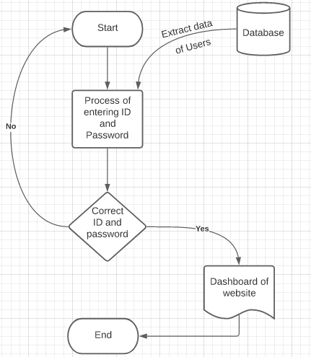

Figure 4.1

* Likewise, after getting access to admin side, professors here can add new students and can edit their profile through their id. They can also add some of the documents for the students so that they can download or view that document. Here, administrators can also add some of the notices regarding some general information which all students should know. And they can edit that notices too.

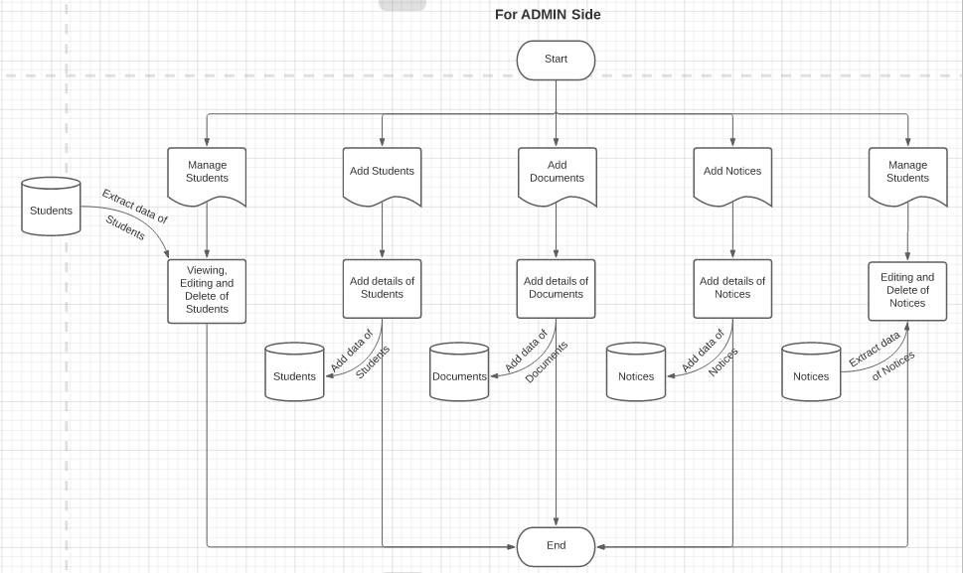

Figure 4.2

* Likewise, after getting access to student side, students here can edit their profile through their id. They can also view some of the documents which are uploaded by the faculties or professors and they can download or view that document. Here, they can also view their own profile too. Students can also see the general notices that is given by the administrative department and will pop upon dashboard page every time.

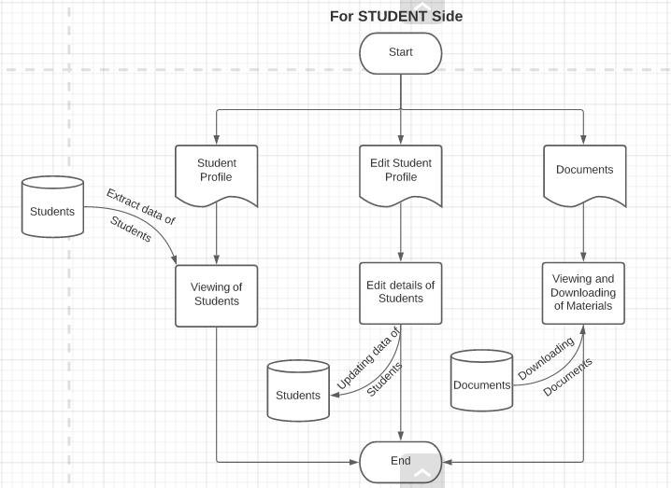

Figure 4.3

**CHAPTER 5: IMPLEMENTATION AND TESTING**

**5.1 Implementation of Project**



Figure 5.1

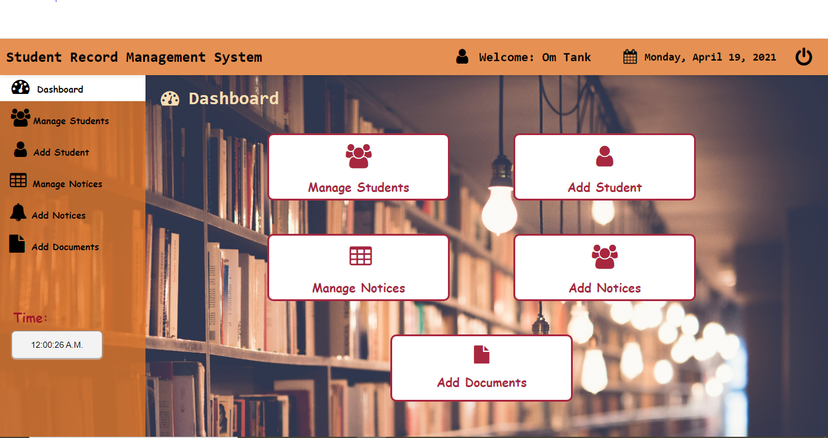

Figure 5.2

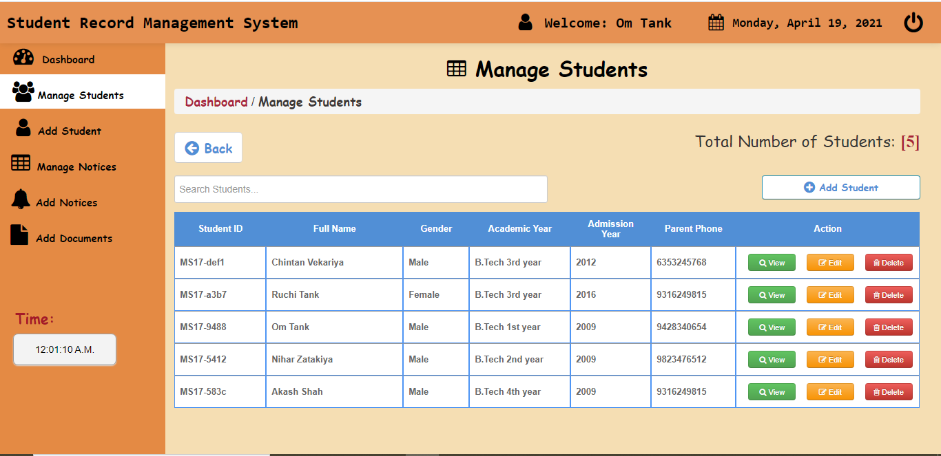

Figure 5.3

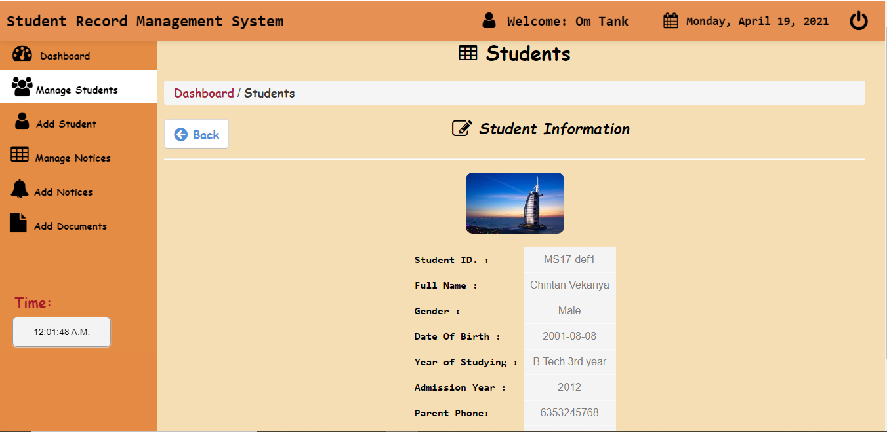

Figure 5.4

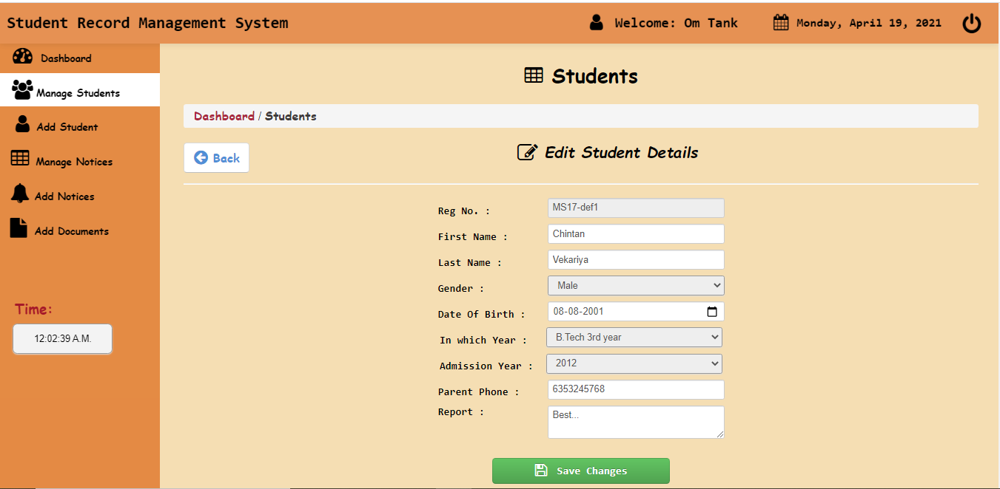

Figure 5.5

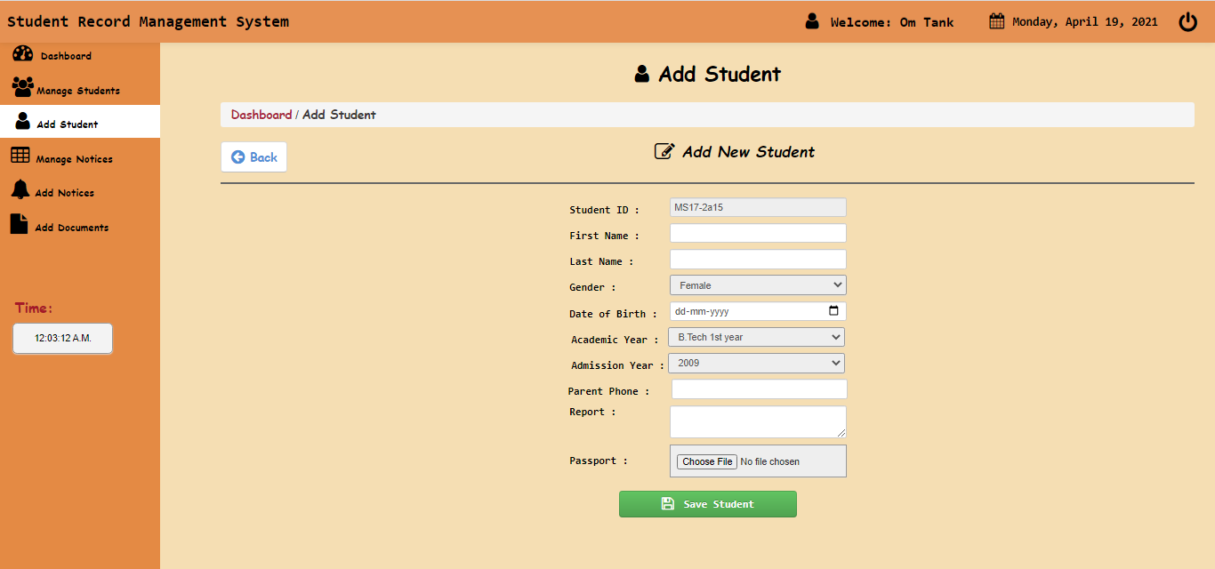

Figure 5.6

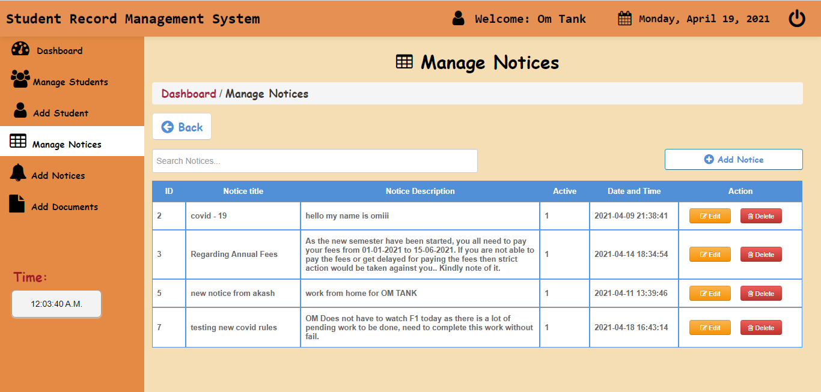

Figure 5.7

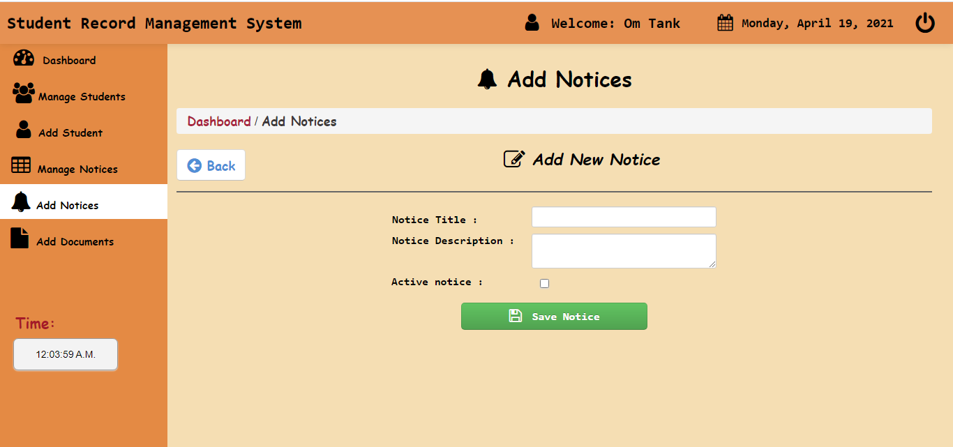

Figure 5.8

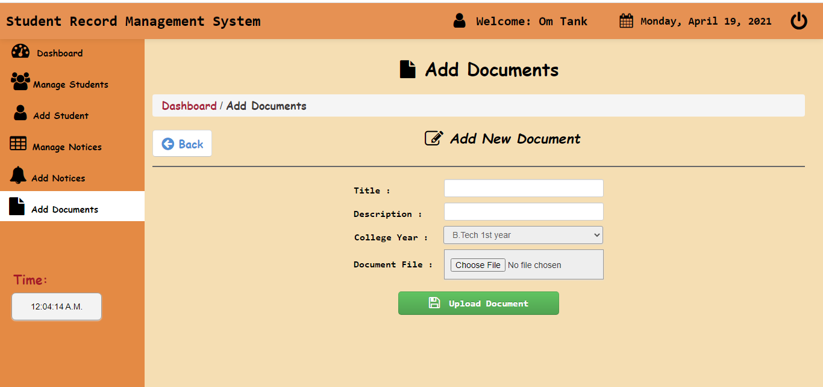

Figure 5.9

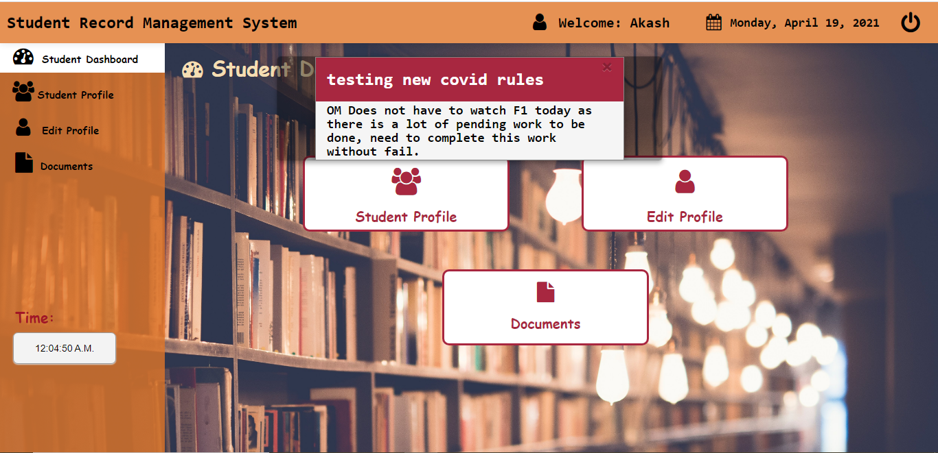

Figure 5.10

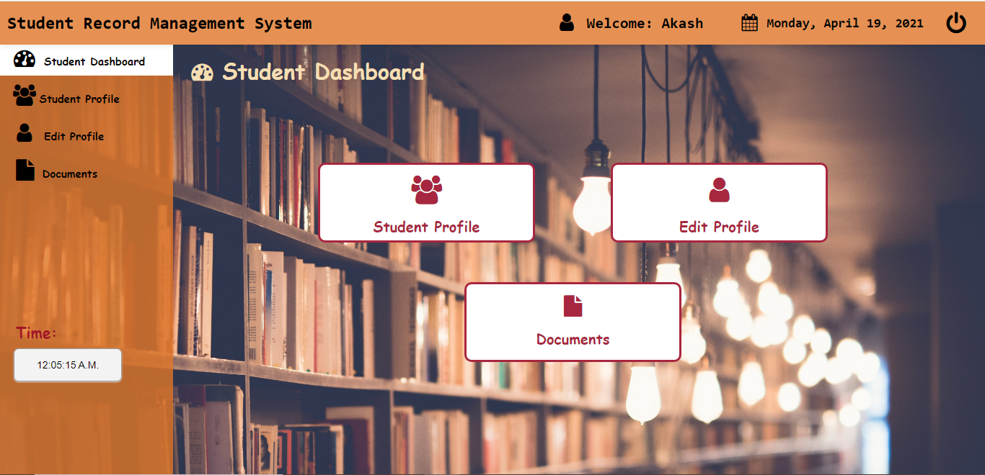

Figure 5.11

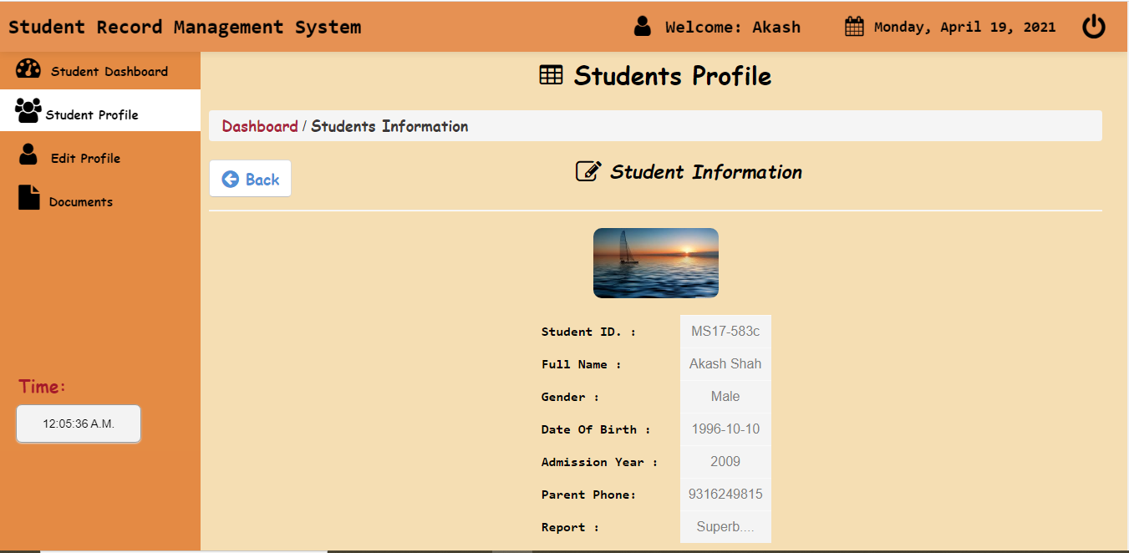

Figure 5.12

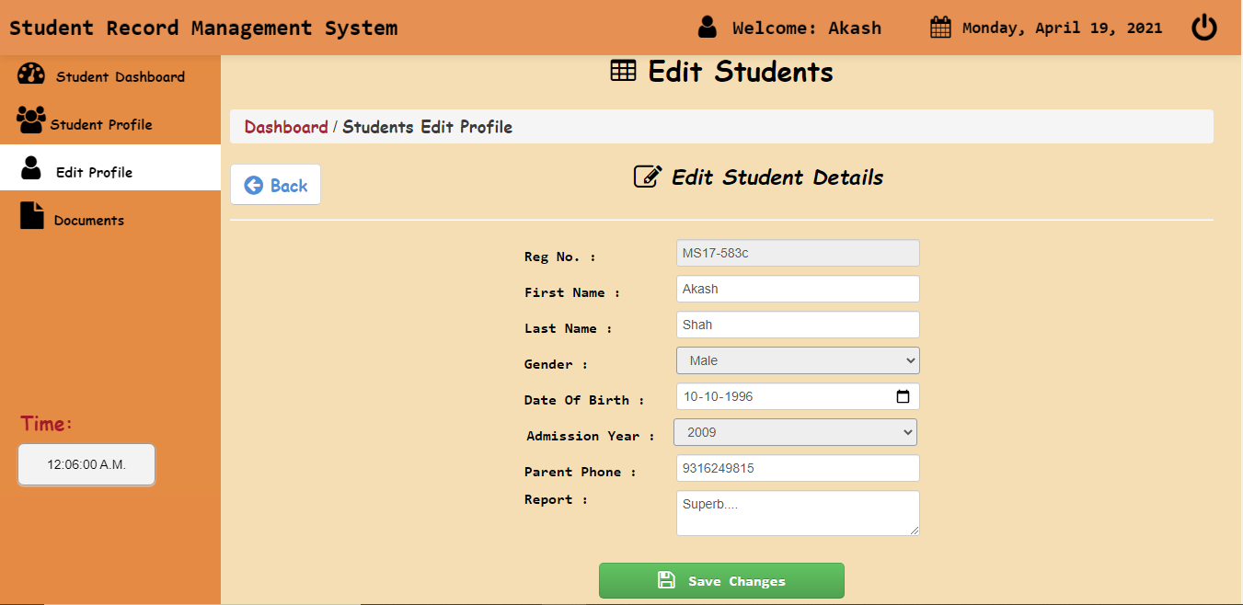

Figure 5.13

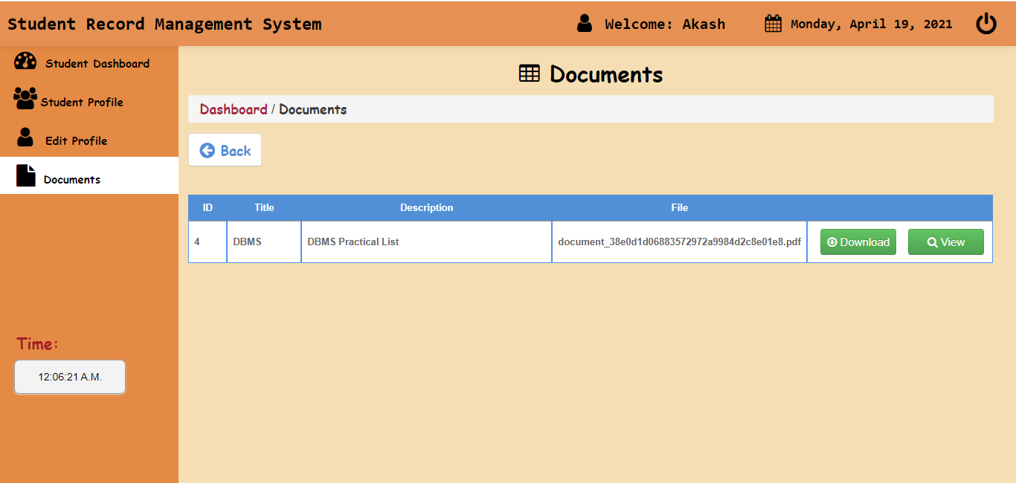

Figure 5.14

**CHAPTER 6: FUTURE PERFORMANCE**

**ENCHANCEMENT**

**6.1 Predictions of the Website in Future**

* Attendance can be filled and seen just in a single click.
* Evaluation of lecture counting will be much easier.
* Teachers and Students can see easily where the lecture is going to be held which makes it easier to see the current lecture and can save time.
* In future, students can also be able to upload or download notes.
* We will see the entire system more interactive and also be able to give statistics data.
* We can run the entire system in any operating system and also we have an android application of this entire system.

**CHAPTER 7: CONCLUSION**

**7.1 Self – Analysis**

According to us, this project is completed with the primary functionalities as specified earlier, but then again there is a lot more than this which can be done. So, then it is a challenge to further develop it in to full-fledged website as it was challenge to develop up to this very stage. As we know that website can also be build using other tech. and languages like python but we used PHP and using this we learned new language with the challenges. Due to lack of skilled knowledge, project cannot be fully completed so far. This technology will provide us an amazing environment for Web Development and will help a lot.

**7.2 Problems and their Solutions**

* **Lack of full knowledge about the technology**

No clear ideas of how the environment is created from scratch, textured properly into unity. These can be achieved only by more study about web designing aspects and technology.

* **Lack of knowledge about the Database**

No clear ideas of how to create Database or how to run it. So, we have to learn from scratch only. While these takes a lot of time and cannot manage the time over the project. These can be achieved if any one of us would know something about the Database.

**7.3 Summary**

After conducting the research, the data gathered which includes the research method used; the respondents, the research instrument and the statistical tool used were summarized. The findings of the study were also presented in this section.

The study deals with the development of an automated student record system for college level. The objective of the study is to develop an automated student record system that is accurate, fast and accessible. The study aimed to:

1. Minimize the manual system in record keeping and issuance of student’s grades.
2. Eliminate the lag time between the submission of grades by the subject teachers and the department head to the registrar, thus preventing of delay in submission and issuance of grades.
3. Provide a system that can be used by the faculty, department head and the registrar’s personnel.
4. To develop a record services using database system in storing student grades. The study was conducted to assess the registrar keeping the records of the students in the college level, the current methods and processes used by the registrar in keeping the records of the students, and the problems encountered by the students, faculty, as well as, the registrar with regards to the need in securing student’s grades and grade reports from alteration or loss, issuance of grades at the end of the semester, and submitting error-free grades by the faculty.